Water Resources Allocation in Central Chile

Field Reconnaissance and Hypothetical Allocation Tools

Submitted by

List authors alphabetically

# TABLE OF CONTENTS

TABLE OF CONTENTS 2

LIST OF TABLES 3

LIST OF FIGURES 3

EXECUTIVE SUMMARY 4

INTRODUCTION 5

BACKGROUND AND METHODS 6

LOCATION 6

PRECIPITATION 8

SOIL PHYSICAL PROPERTIES 11

RECONISSANCE METHODOLOGY 13

ALLOCATION METHODOLOGY 13

PETORCA VALLEY – A CASE STUDY 16

APPENDIX 21

# LIST OF TABLES

Table 1. Rainfall Depths at Juan Santa Maria International Airport in January 2017. 11

# LIST OF FIGURES

Figure 1. Overview map of Chile. The class spent entire reconnaissance in Central Chile in and near Valparaiso 7

Figure 2. Agricultural Regions. Aconcagua, Casablanca, and Maipa were visited on field trips. Aconcagua Valley is used as the LP Model Framework. 8

Figure 3. Annual Rainfall Map for Costa Rica. from: http://costa-rica-guide.com/travel/weather/weather-map-rainfall/ 9

Figure 4. Rainfall Depth - vs- Month Polar Plot for San Jose' Metro Region 10

Figure 5. Rainfall Depth vs. Month Polar Plot for Arenal Volcano 10

Figure 6. Rainfall Depth vs. Month Polar Plot for Central Pacific Coast 10

Figure 7. Rainfall Depth vs. Month Polar Plot for Central Valley Region 10

Figure 8. Soil Map for Costa Rica. 12

# EXECUTIVE SUMMARY

words

# INTRODUCTION

words

# BACKGROUND AND METHODS

Background intro

## LOCATION

Figure 2 is a map of Chile . The middle third of the map corresponds to Central Chile. The class studied entirely in Central Chile, specifically near Valparaiso and Santiago.

**Figure 2** is a map closer to the study area showing the primary valleys in the area. The class went on field trips to Aconcagua, Casablanca, and Maipo valleys. The allocation case study is based on observations in Aconcagua Valley, but the generalizations are extensible to the other valleys.

Casablanca valley differs from the other two because it does not have a river (surface water expression) that exits the valley. The entire functional water supply in the valley is derived from groundwater.

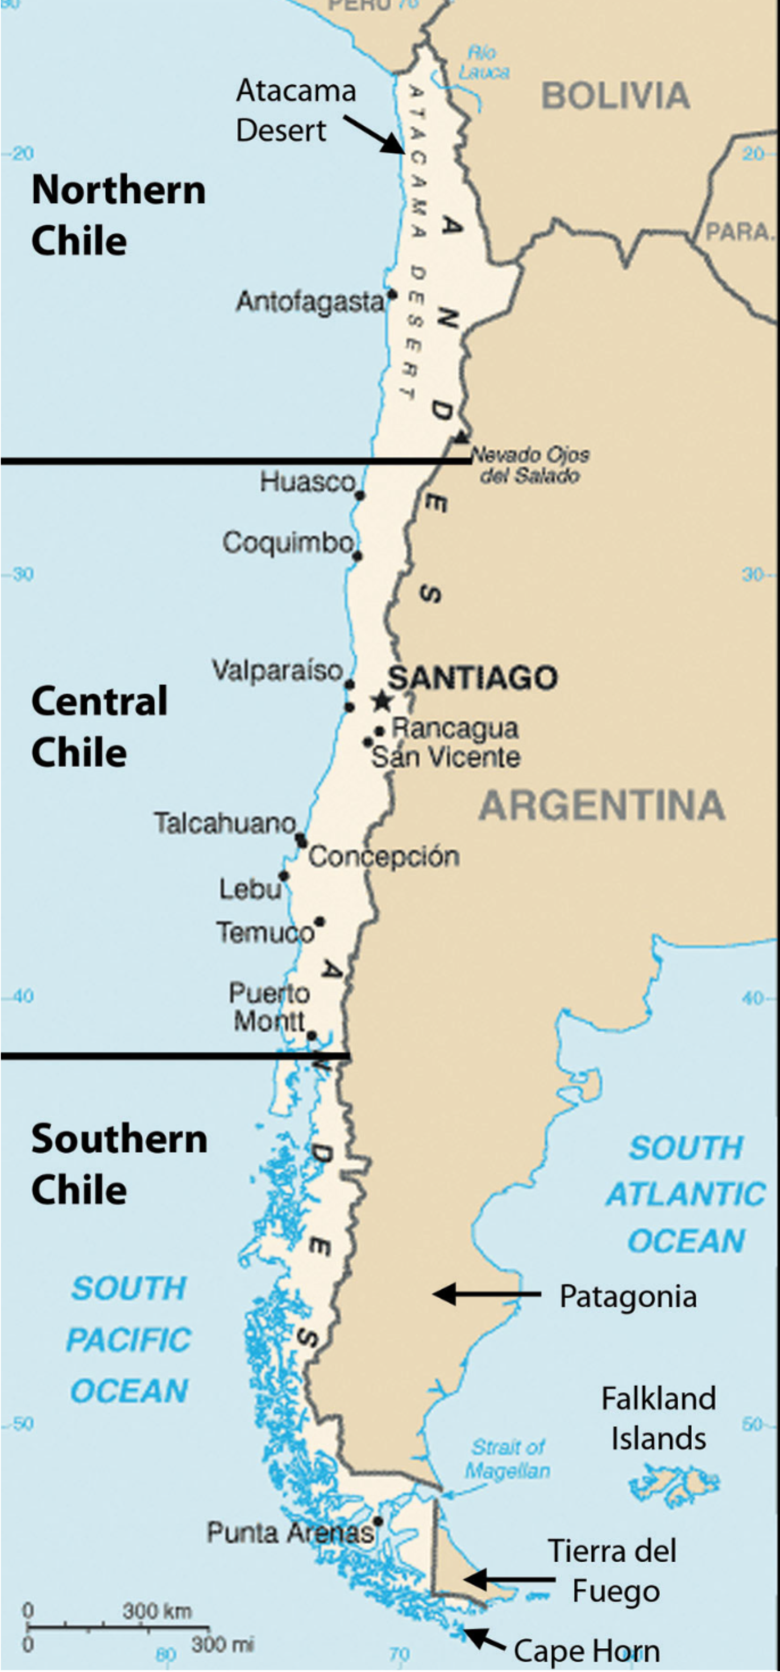

Figure 1. Overview map of Chile. The class spent entire reconnaissance in Central Chile in and near Valparaiso

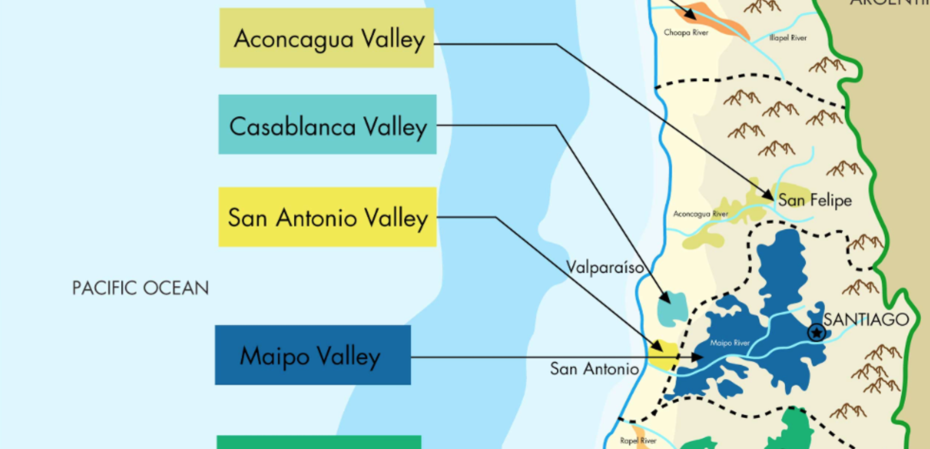

Figure 2. Agricultural Regions. Aconcagua, Casablanca, and Maipa were visited on field trips. Aconcagua Valley is used as the LP Model Framework.

The North side of Aconcagua is dominated by a mountain range, and the most notable mountain is La Campana, which overlooks much of the valley.

## PRECIPITATION

Long droughts are common in Central Chile, and during the visit, the region was exiting from a decade long drought. In central Chile, starting from the Santiago region, the climate becomes almost **Mediterranean** in the narrow strip of plain, that is, mild and rainy in winter, and warm (or hot) and sunny in summer. Along the coast, however, the influence of the sea makes the summer cool: in **Valparaiso**, the average temperature goes from 17.5 °C (63.5 °F) in January and February, to 11.5 °C (52.5 °F) in June and July.

Table 1 is a listing of average precipitation along the coast. The pattern shows evidence of a wet and dry season; the dry season spans nearly ½ the year.

Table 1. Precipitation in Central, Coastal Chile.

|  |  |  |  |  |  |  |  |  |  |  |  |  |  |
| --- | --- | --- | --- | --- | --- | --- | --- | --- | --- | --- | --- | --- | --- |
| **Valparaiso** | **Jan** | **Feb** | **Mar** | **Apr** | **May** | **Jun** | **Jul** | **Aug** | **Sep** | **Oct** | **Nov** | **Dec** | **Year** |
| Prec. (mm) | 0 | 0 | 5 | 15 | 55 | 85 | 110 | 60 | 25 | 10 | 8 | 1 | **373** |
| Prec.(in) | 0 | 0 | 0.2 | 0.6 | 2.2 | 3.3 | 4.3 | 2.4 | 1 | 0.4 | 0.3 | 0 | **14.7** |
| Days | 0 | 0 | 1 | 2 | 9 | 9 | 8 | 8 | 5 | 2 | 1 | 0 | **45** |

Table 1 is a listing of average precipitation in Santiago, about 100km inland from the coast. The pattern is nearly the same; the total depth is about 10% less than at the coast.

Table 2. Precipitation in Central, Inland Chile.

|  |  |  |  |  |  |  |  |  |  |  |  |  |  |
| --- | --- | --- | --- | --- | --- | --- | --- | --- | --- | --- | --- | --- | --- |
| **Santiago** | **Jan** | **Feb** | **Mar** | **Apr** | **May** | **Jun** | **Jul** | **Aug** | **Sep** | **Oct** | **Nov** | **Dec** | **Year** |
| Prec. (mm) | 0 | 1 | 3 | 10 | 40 | 70 | 85 | 50 | 22 | 13 | 9 | 2 | **313** |
| Prec.(in) | 0 | 0 | 0.1 | 0.4 | 1.6 | 2.8 | 3.3 | 2 | 0.9 | 0.5 | 0.4 | 0.1 | **12.3** |
| Days | 0 | 0 | 1 | 3 | 5 | 7 | 7 | 6 | 5 | 2 | 1 | 0 | **37** |

FIGURE XX is a table of climate classification versus precipitation and evapotranspiration. Using this figure, the climate in the study region would classify as Arid – indicative that water availability will be a long-term issue; hence the need for management tools.

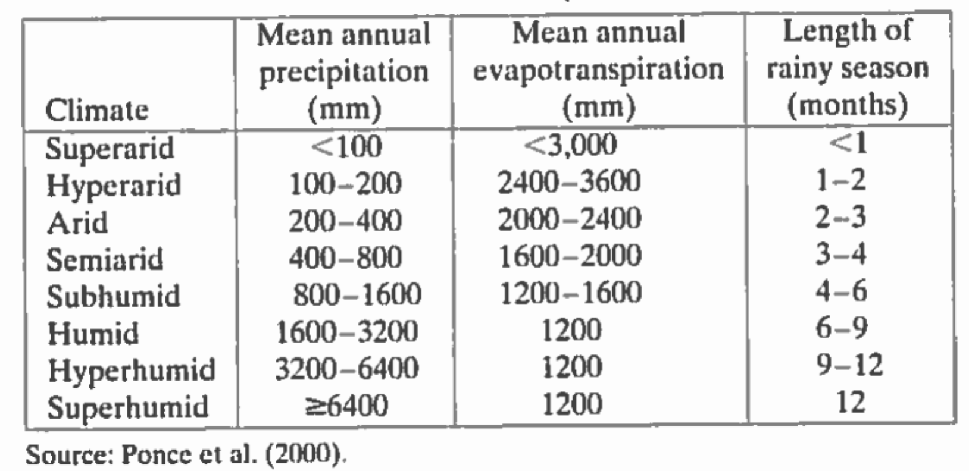

Figure 3. Climate Classifications

## SOIL PHYSICAL PROPERTIES

Soil mapping in Chile is ongoing. FIGURE XX is an image showing the soil texture in the region. The study area is comprised of soils of 20% Clay, 30% Silt and the remainder sandy materials. This texture would be expected to be well draining. The soil has moderately low carbon content.

In the actual field study areas the presence of the river environment and steep hillsides suggests the bottom lands are alluvium. The hillside components are unknown, but on the La Campana field trip the exposed rock appeared to be metamorphic, much like the greywacke, shale, and chert along the California coast.

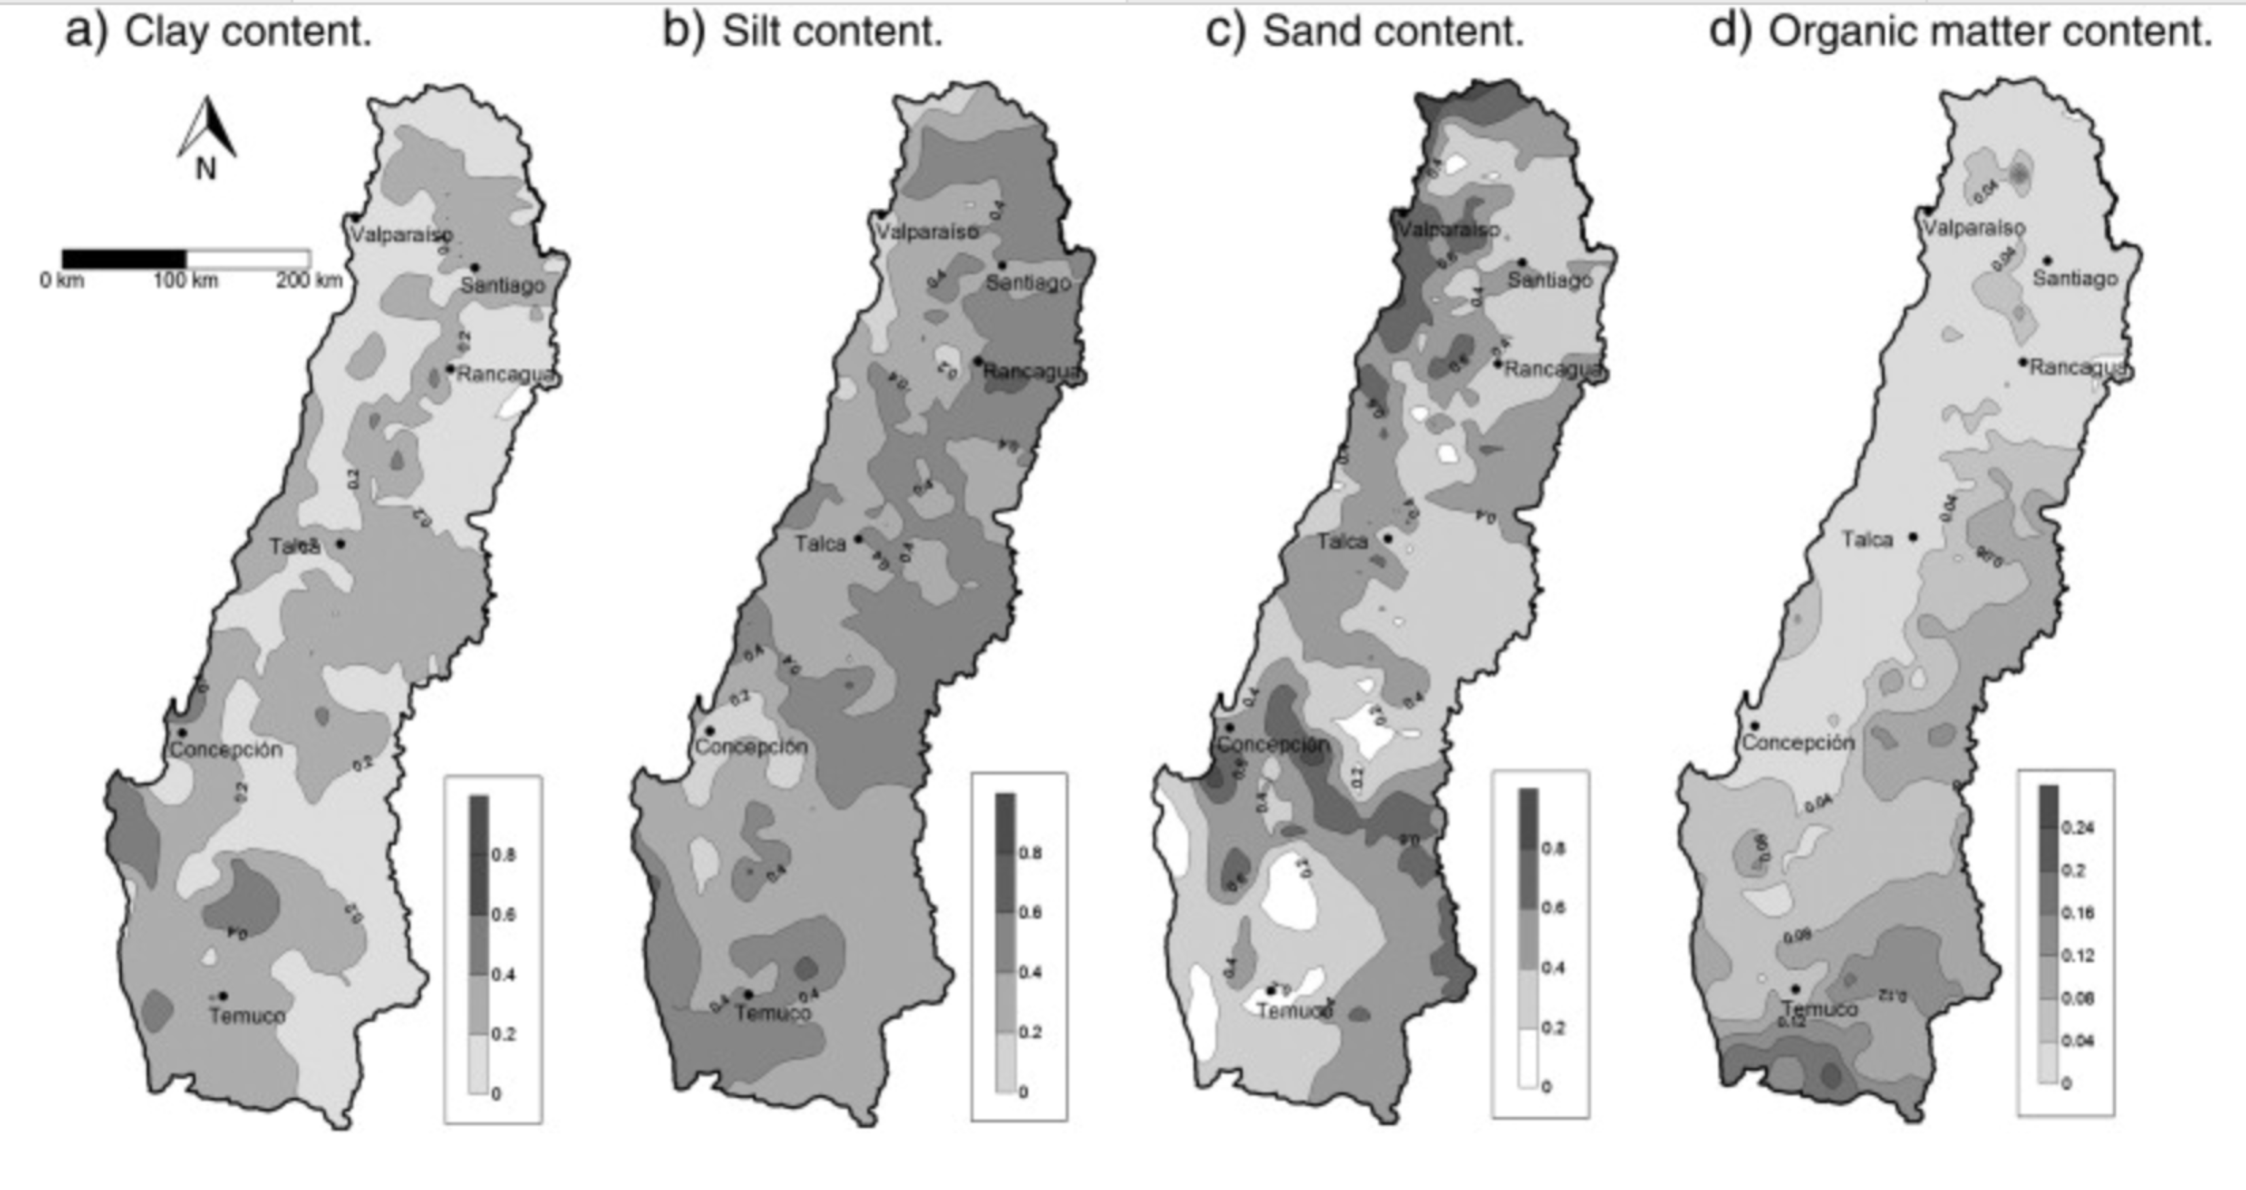

Figure 4. Central Chile Soil Properties

Figure 6. Soil Map for Chile.

.

## RECONISSANCE METHODOLOGY

The team performed reconnaissance studies of the various locations indicated on Figure. The reconnaissance comprised making the following observations

1. Field observation using notes and photography to document various features relevant to water resource allocation.
2. Preparation of daily trip reports to capture perishable observations.

The reconnaissance sites are grouped into two categories: destination/pristine and urban. The one beach visited is more urban than pristine, but is classified as destination for this report.

## ALLOCATION METHODOLOGY

In parallel with the reconnaissance trips, lectures focused on economic evaluation of resources and readings on welfare[1] economics were conducted to build a computational framework for future extension (using real data when available).

Linear Programming as implemented in R was implemented in the framework tool to learn how such allocations can be made with sufficient information.

As part of future allocation, the class participated in the collection of tree-core samples, their preparation for analysis, and in the analysis. These samples represent a way to extend the limited historical record in Chile for estimating water availability in the case study basin.

# FIELD TRIP REPORTS

Jhjhl;h;lkj;lkj;lkj

## Valpariso

Cultural ecozones. Water not an issue. Water supply by pumping to hilltops, gravity to bottom areas at port. Maintenance because of weak soil structure, steep hills, and dense infrastructure is an issue.

## La Campana

Trip from coast to 900M elevation to collect tree cores as part of a dendrohydrologic campaingn to reconstruct historical weather pattersn.

## Casablanca Valley

Trip to commercial winery. Water supply is entirely from groundwater resources. The valley also produces other components than wine grapes.

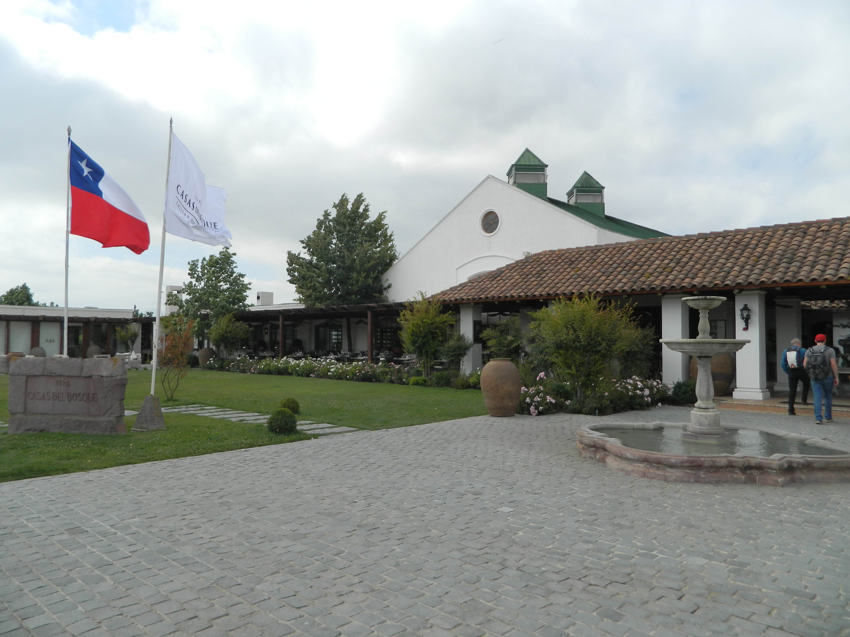

Image 1: Entrance of Casablanca Valley

Most vineyards have large rivers or water sources to be able to irrigate heavily whenever needed. However, being in a region with mountains and no rivers, it is difficult for Casablanca Valley to irrigate heavily. For their water allocation they utilize several different techniques to ensure their grapes will be prosperous. The valley has only one water supply and that is the reservoir underground. This is replenished each year with rainfall that occurs in Chile’s winter with rain being quite rare in the summer. Usually, the valley utilizes about 60% of this reservoir. However, this percentage can vary depending on how much rain they receive.

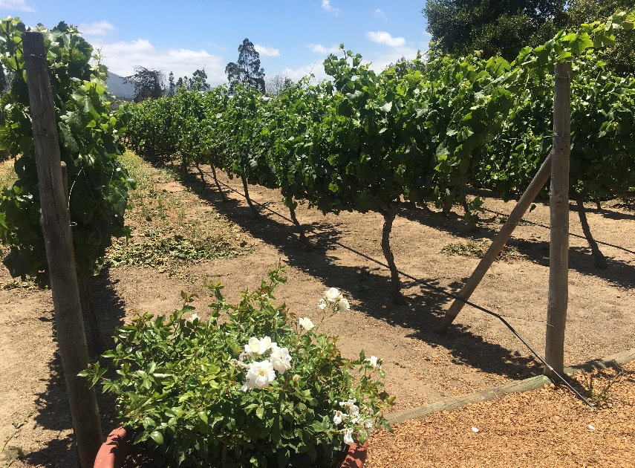

Image 2: Casablanca Vineyard vines with pipes at bottom used for drip irrigation

The amount of water needed to irrigate the grapes is tested through seeing how much moisture is in the soil. This indicates if more or less water is needed for the plants. Therefore, it is extremely essential the valley understands how much water they have and how much they can allocate to differing parts of the valley. The pipe that drips water is accurate for this exact reason. The pressure starts off higher at about 2.5 psi at the beginning of the pipe and ends closer to 1 psi. The change is accounted for by valves that can control pressure and drip at the same rate, so that measuring the amount of water each plant is getting is correct and precise.

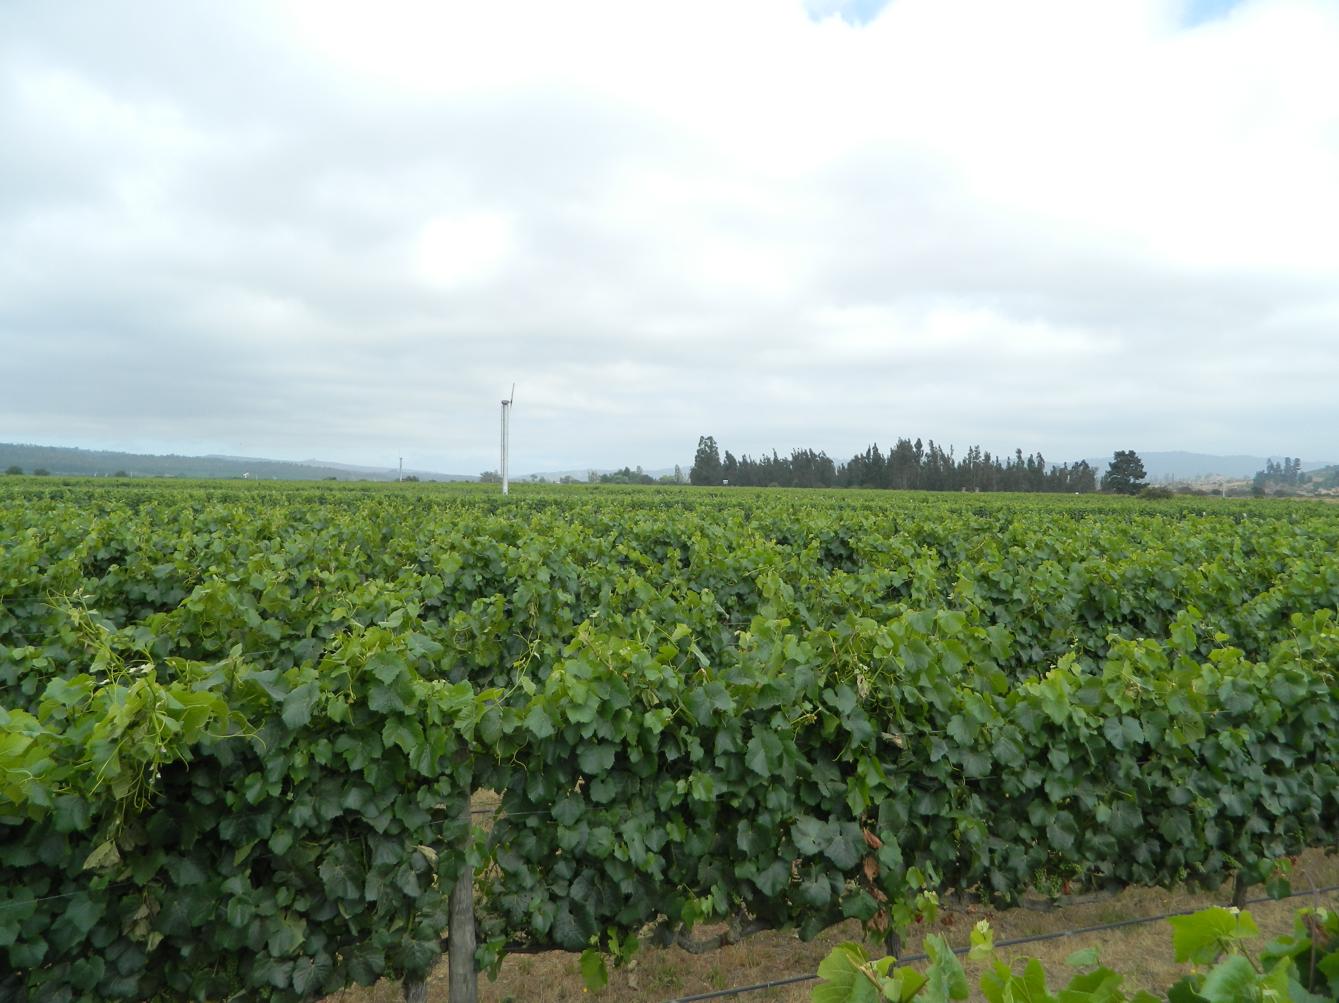

Image 3: Fan in the fields at Casablanca Vineyard

One way the water is allocated at the valley is by utilizing a large fan that operates from natural gas to make sure the plants do not get frost on them by circulating the hot air with the cold air. During this process the hot air is pulled in a downward motion while the cold air is pushed to the top. Typically, this causes the temperature to be raised by two to three degrees stopping the formation of frost. This prevents the valley from having to use more water in another process that pumps water to defrost plants. Although the natural gas is expensive, it is not as limited as the essential water supply.

## Petorca Province (Aconcagua River Valley)

Four water users; agroculture, mining, industry, and municipal. Recent (last 10 years) drought is problematic. About ½ all wells are undocumented. Interceptor drains on hillsides direct water away from bottomlands further reducing available water the historical users.

## Lago Penuelas

Sdkjaglkjglkjdgla’ksjgd

## Ventanas and Aguas Claras

Sad;gj;jgd;’jgs;’sdgj

## Santiago

# ACONCAGUA VALLEY CASE STUDY

Case study

Chance constrained LP to illustrate allocation.

4 Users.

Need Denrrohydrology

CONCLUSIONS AND RECOMENDATIONS

REFERENCES

# APPENDIX

1. Welfare in the sense of welfare of a nation – a way to maximize benefit for the entire nation as a whole.